Alcohol taxes are a particularly tricky tax to get right. I have therefore done several simplifications.

It is important to recognize that there are several different kinds of taxes.

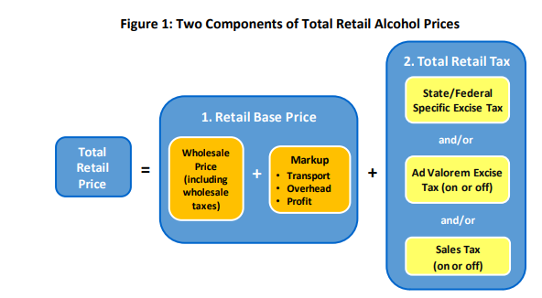  
Source: [TOTAL TAX: A SUGGESTED METHOD FOR CALCULATING ALCOHOL BEVERAGE TAXES (nih.gov)](https://alcoholpolicy.niaaa.nih.gov/sites/default/files/file-page/total_tax_a_suggested_method_for_calculating_alcohol_beverage_taxes.pdf)

State taxes are:

Volume*state specific excise tax + Retail base price*(Adv.excise tax + Sales tax rate)

What complicates matters, is that there may be a substantial wholesale tax rate baked into the Retail base price.

Wholesale price*(1+wholesale adv.tax) + markup = Retail base price

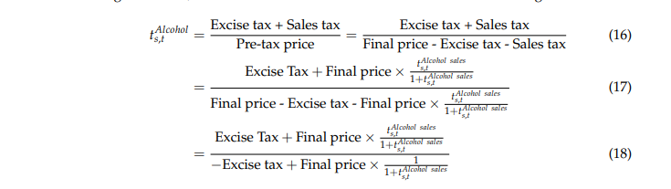

For the sake of simplicity, I just treat the wholesale tax rate as an additional adv.excise tax multiplied by the Retail base price*0.6, to compensate for a very rough estimate of the markup. [Margin vs. Markup: Calculating Both for Your Alcohol Brand - Overproof](https://overproof.com/2021/08/30/margin-vs-markup-calculating-both-for-your-alcohol-brand/)

Some states have an on-site adv.excise tax and an adv.excise tax off site. Some just have one. We assume that the alcohol market is about a 50/50-split. [How The COVID-19 Pandemic Is Upending The Alcoholic Beverage Industry (forbes.com)](https://www.forbes.com/sites/joemicallef/2020/04/04/how-the-covid-19-pandemic-is-upending-the-alcoholic-beverage-industry/)

Linearized- and aftertax rates

I calculate all the linearized- and aftertax rates for each alcohol separately and then take the average of it. This choice has a minor effect on the aftertax rates.

Control states

The taxes for the control states are calculated differently. For each state, I first take the sum of tax revenue from alcohol sales and net profits from liquor stores. Then I divide this sum by the total gallons of alcohol consumed in the state. This gives a crude total tax amount per gallon of alcohol.

Federal alcohol taxes

Prices calculated as unweighted averages of all states for each year.